**API End Points and Communication**

**Day 14: 25 March 28**

Rest full web service also known monolithic service.

E commerce application

Login module

Login controller, login service login entity and login dao or repository

SignIn, SignUp, ChangePassword etc.

Product module

Product controller, product service, login entity, product repository

CRUD Operation etc.

Order module

Order controller, order service, order entity, order repository

Micro service : in micro service we focus only on particular module rather than whole application. That module we deploy independently.

In micro service it is not mandatory all modules develop using same language.

It is not mandatory we need to use same database. We can use same or different.

In micro service we can use same language or different language. Same database or different database. We can deploy all those modules independently.

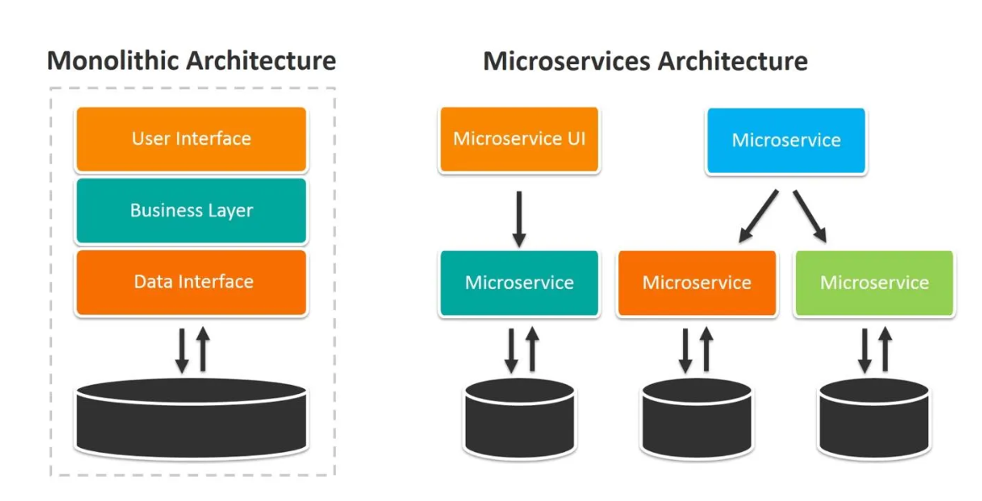

In micro service we deploy every module independently and those modules run on different port number. Base upon requirement those module interact with each others to share the data.

Spring boot provided 2 modules

1. Spring cloud
2. Spring micro service

To achieve micro service concept using spring boot. Spring boot provide one of the open source server ie Eureka Server.

Eureka Server is a type of server which help to deploy more than one micro service created using spring boot. Which keep the track or health of all micro service.

1. First create Eureka Server.
2. We can create more than one micro service project.

1st project : Eureka Server

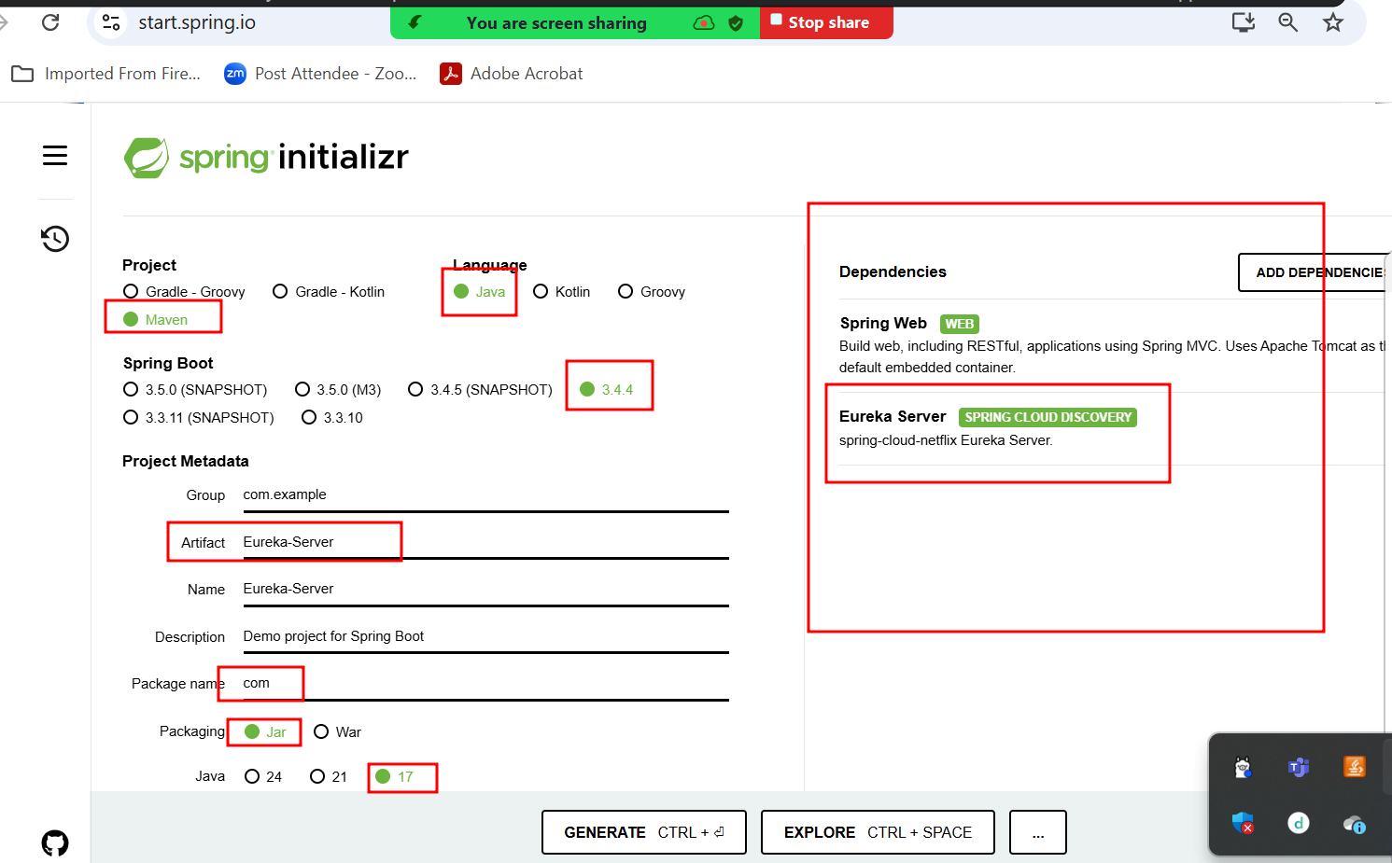

Create micro service project which provide simple end point. Running on port number 8181

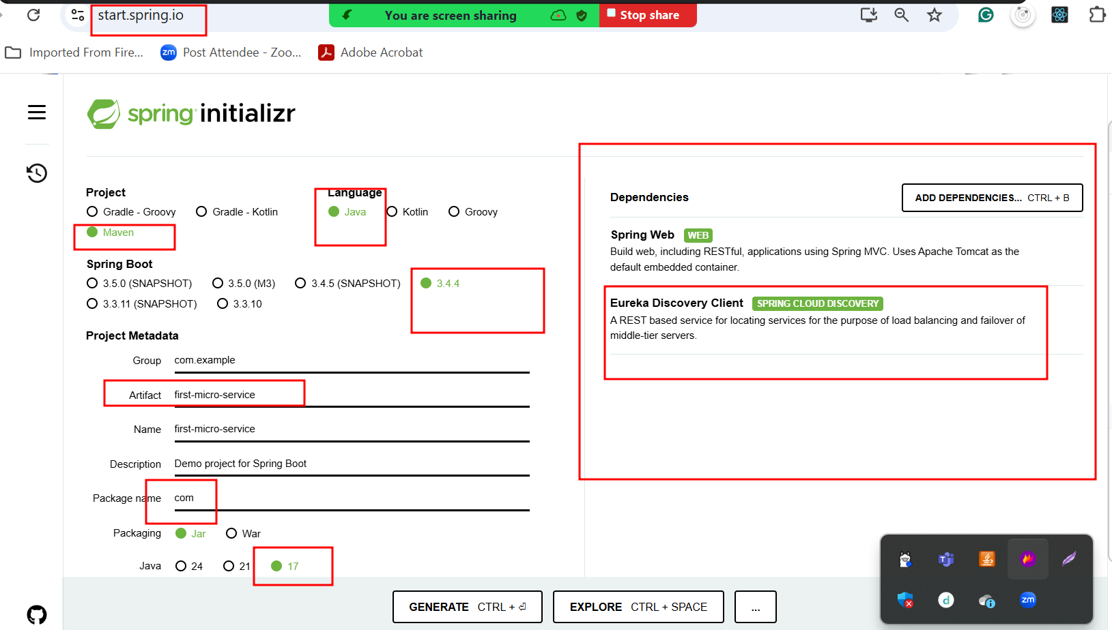

Create micro service project which provide simple end point. Running on port number 8282

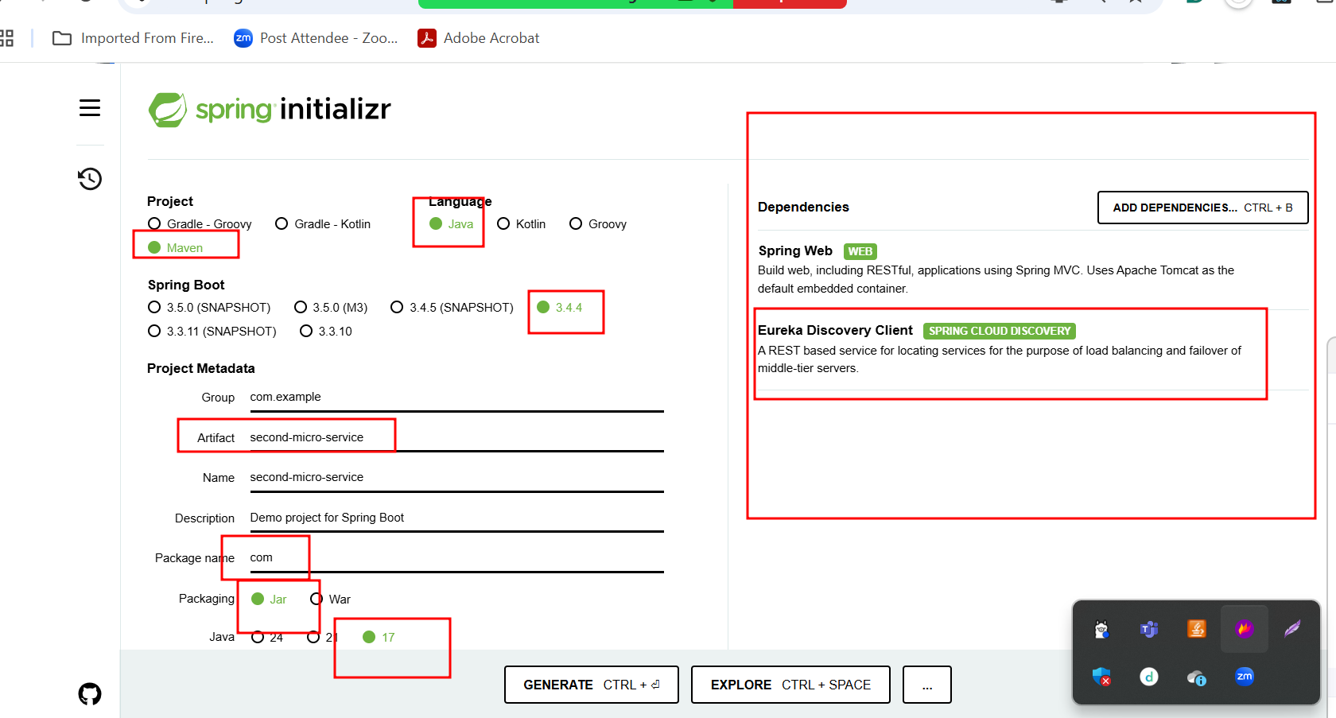

Eureka Server

8761 -🡪 port number

Account Micro Service

8383 port number

Starter 🡪web starter

Starter 🡪 jpa starter

Dependency 🡪 mysql connector

Starter 🡪Eureka discovery client

Create account Post method accno pk, name, emailid(unique),amount

FindBalance get method using accno we find the balance

Withdraw put method accno and amount to withdraw

Deposit put method accno and amount to deposit

FindAccountNumber get method if we pass emalid we want account number

**MySQL -🡪 Database**

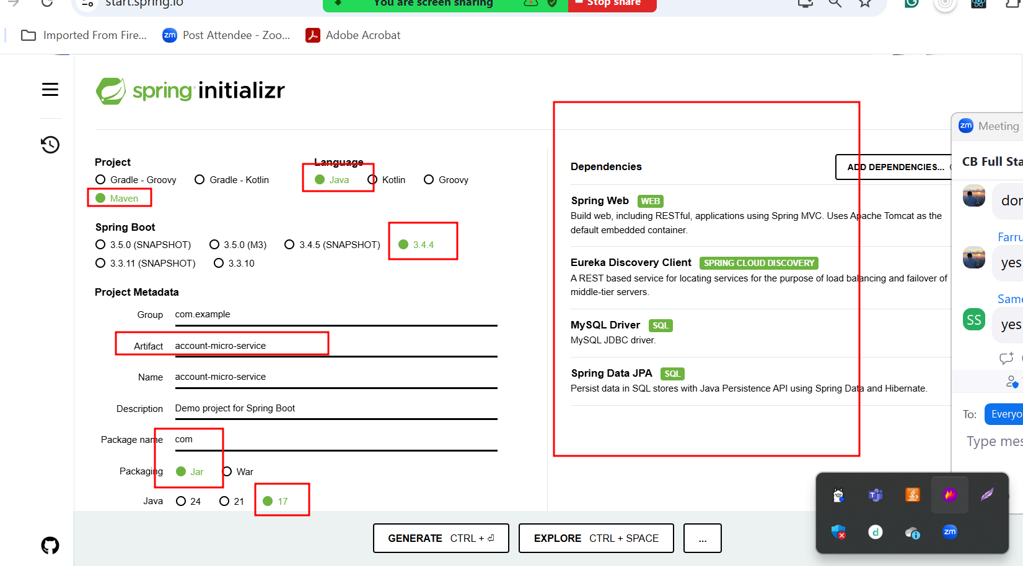

Paypal or Paytm or Gpay

8484 port number

Starter 🡪web starter

Starter 🡪 jpa starter

Dependency 🡪 h2 connector

Starter 🡪Eureka discovery client

Create paypal account -🡪

**H2 🡪 Database in memory database or Mongo DB or any other database.**

Create account -🡪 paypal id auto increment, accnumber :

8484 port number we pass emailid to create paypal account. This emailid pass to 8383 port number for account service to get account number. If account already present that account number and paypal id which created as auto increment we store in h2 database.